MZIMBA NORTH PROVISONAL MARKING KEY FOR PHYSICS FORM 2 TERM 1 (2025-2026)
SECTION A (20 Marks)
1.B 2. B 3.D, 4. B 5.C 6. D 7. B 8. A 9. D 10.C 11.D, 12.C 13.A 14.C 15.A 16. B 17.A 18. D 19.A 20. A
SECTION B (50 marks)
21.a. is the systematic process of testing ideas or finding an answer to a question and observation.
b.i. To get the relationship between the mass and the age of children
ii. A child’s mass increases as the age increases.
22.a. To avoid stepping on pieces of broken glass accidentally
- To prevent damage of materials and chemical.
- To prevent people from being injured
- To prevent death of people working in and around the laboratory
- Prevents damage of the laboratory
b.i. Toxic
(ii)- wear chemical-resistant glovers to prevent skin contact
- Handle equipment with tongs or tweezers to minimize direct contact
- Protective clothing, wear lab coats, coveralls, or other protective clothing.
23.i. The slope = change in y
change in x
y₂ – y₁
_{X2 – X1}
2 – 0
10 – 0
2/10
0.2 ohm/cm
ii. As the length of the wire increases resistance also increases.
e. 2km = 2km x 100000cm
1km
= 2 x 100000cm
= 200,000cm

24.a. This is the advice or an interpretation by specialist with experience in specific area about the scientifield evidence pertaining to the subject or study.
b.
- helps to answer questions where evidence is not available.
- Help with alternative way of the study in case results are not what we were advocating for.
- Help with identification of errors
- Help to identify area which requires close attention in the study
25.a. To investigate whether air expand or contract when cooled.
b. It will drop as the test is cooled
c. because the molecules slow down and move closer together.
26.a. is the ratio of the total mass of a substance to the total volume of substance.
b. survival of aquatic organisms in freezer lakes and ponds.
-bursting of water pipes
-weathering of rocks
-floating and sinking

27.a. Energy cannot be destroyed or created but changes from one form to another.
b. (i) Kinetic energy
(ii) Because velocity of a pendulum is maximum
(iii) Potential energy → Kinetic energy → Potential energy
(iv) Potential energy -> Kinetic energy -> Electrical energy
28. a. B and C
b. Voltages are equal in a parallel circuit.
c.
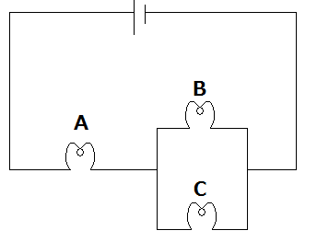

29. a. The law of magnetism states that unlike poles attract each other while like poles repel each other.
b. Suspend a bar magnet using a string in air
Allow it to come to rest
Observe that upon coming to rest it points north – south direction
A pole point north is a north pole while a pole point south is a south pole.
Or a diagram can be used as below

i.Set up the apparatus as shown below.
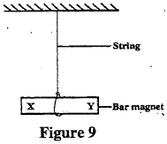
ii. Suspend the magnet and Push the magnet slightly so that it can swing.
iii. Wait until it stops swinging.
Note the direction in which it comes to rest. The pole that points north is the N seeking pole and the pole that points south is the S-seeking pole.
30.
. 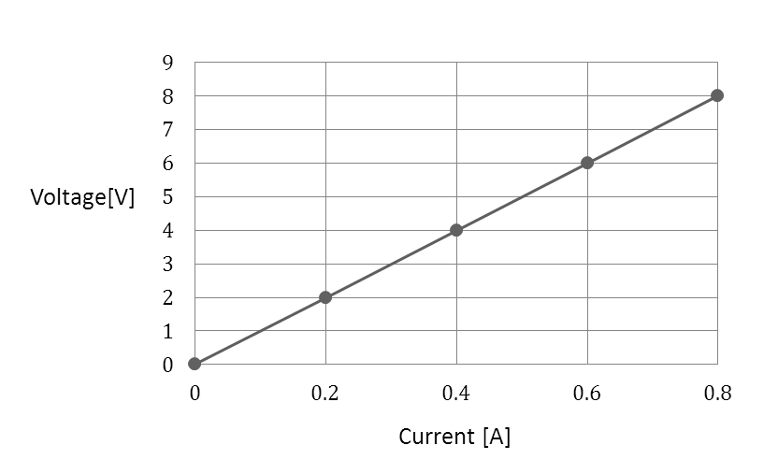

SECTION C ( 30 marks)
31. set up the experiment as shown below.
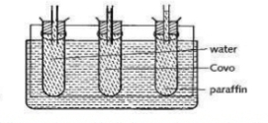(3mks)
-fill three identical test tubes with water, cooking oil and paraffin(1mk)
-cork them with a cork fitted wih capilarry tubes .(1mk)
-place the test tubes in a hot water bath and observe the levels of the liquids .(1mk)
-if the level of cooking oil is highest then it expands more than water and paraffin.(1mk)
b.Reducing temperature increases the intermolecular force holding the particles of a substance, hence distance between the particles get reduced, this reduces volume of the substances but mass remains the same hence density increases
32a.- Building fences, Fences are built with gaps between the panels to allow expansion without bulging in hot days
-Railway construction, when railway is being constructed gaps are left between the gaps so that the railway line should not bend when it expands in hot days.
- Shrink fitting
b. -Measure the mass of regular metal block using a beam balance
-Measure the length , width and height of a regular metal block using a meter ruler-Calculate the volume of the regular metal block by multiplying the length, width, and the height.
-Calculate the density of the regular metal block by dividing its mass with the calculated volume.
33. heating effect of electric current
Set the apparatus as below

Switch on the circuit to allow the current pass-through water
Observe that the current passes through the circuit by observing the current reading through the ammeter
Observe that after sometime the reading of the thermometer increases
Increase in thermometer reading indicates the heat released as current passes through water in the beaker
This therefore concludes that current produces heat

